Alta Vista Neighborhood Association
Board Meeting
Sept 6, 2023, @ 6:00 PM
Zoom Meeting

Agenda:
- Introduction: need for a new secretary.
- Minutes and Reports: approval past several minutes.
- Technical Committee updates: 133 Hickman email, Funeral Home (not in AV), four properties on Lynwood, wine bar is in remodel phase (email sent).
- Arts Committee: AV sessions, Holiday Party, and brick pathway.
- Contreras fund – Possible investment plan.
- Newsletter and advertising updates.
- Website updates.
- Membership updates.
- Messages from our Representatives: D1 representatives – email correspondence with Ryan Salt about Mark Twain and property on Huisache.
- SAFFE & CODE updates: Officer gave citations for parking on Lynwood Ave & illegal parking near Mark Twain. Responded to Mark Twain traffic. The dumpster for the food truck place has been moved off the easement. The apartment complex's dumpster is still on the easement, but the code said owner will move it. I will ensure by the next assembly meeting that there is a follow-up from code on this issue. See the pictures below of moved dumpster.
- Around the Room: Beacon Hill trail or treat, BH opposition to zoning, D1 Neighborhood Alliance (Nov 4 meeting), outreach during Thanksgiving to elderly and those in need in AVNA, election for new board members, and renewing association membership with the city by Dec(Katie will do this).
Future Dates:
- General Assembly: Sept 27, 2023 @630PM; Erin will be facilitating this meeting.

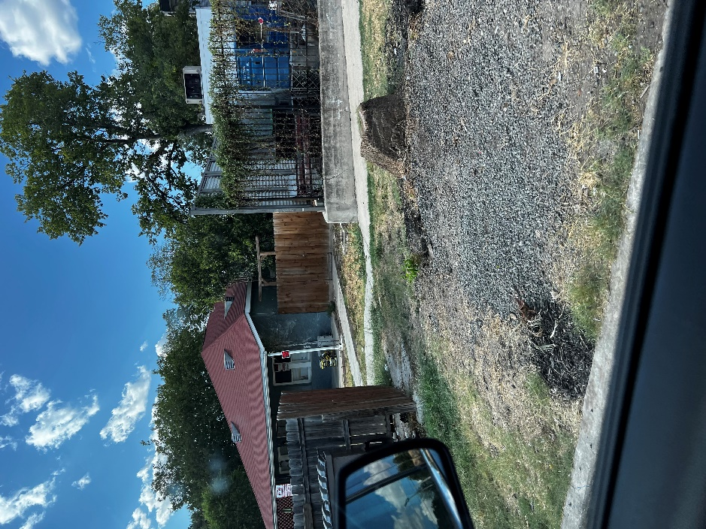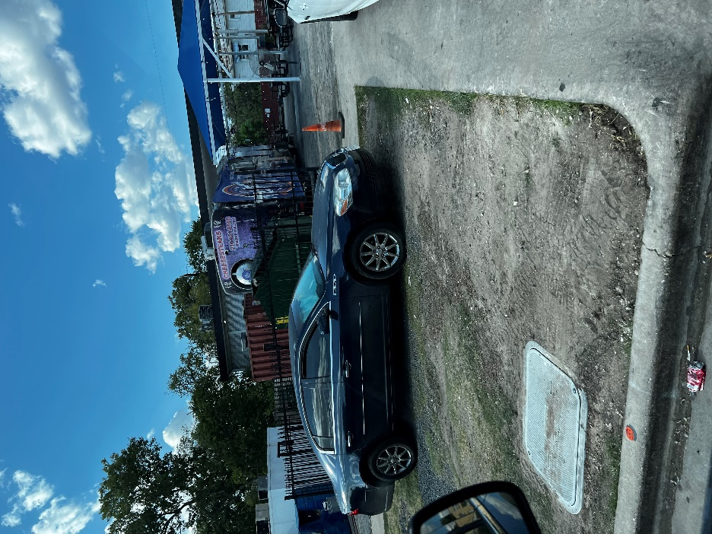
new location
new location
Where dumpster was

Properties:
800 W. Russell- Home is burnt down.
538 W. Woodlawn – Ambulance graveyard.
408 W. Huisache dumpsters violate the conservation district’s policies regarding trash placement.
501 W. Agarita - vacant overgrown considered a hazard. Possible sale of property?
515 W. Mistletoe - trash all over the property's back yard has tents and strange things reported.
523 W. Huisache- Long list of complaints from neighbors sent to AVNA and code. Ryan said city code enforcement went out and issued citations.
527 W. Mistletoe - Outside, the property is covered in debris, equipment, and transients in and out of this building.
402 W. Mulberry - Trash all over the side of the building, the building is not compliant with building codes, and tenants throw trash in the alley.
410 W. Magnolia - The property caught fire last year and is left in a condition that the homeless can assess. It is not in compliance with the conservation policies. Personally have homeless in and out of the property.
741 W Ashby - The old pho sure building-vacant; updates.
910, 912, 914, 916, 920, 930, 940, 942 - Small homes used for railroad workers back in the 1940s. These homes are always problematic with homeless, drugs, trash, etc.

